Getting Started: Running the “Device – Libusb – Generic Driver Demo”

Required Hardware: 1
Configuration 1: PICDEM™ FS USB 1
Configuration 2: PIC18F87J50 PIM 1
Configuration 3: Explorer 16 1
Configuration 4: Low Pin Count USB Development Kit 1
Configuration 5: PIC24F Starter Kit 1 1
Configuration 6: PIC18F46J50 Full Speed USB Demo Board 2
Configuring the Hardware: 2
Configuration 1: PICDEM FS USB 2
Configuration 2: PIC18F87J50 PIM 2
Configuration 3: Explorer 16 4
Configuration 4: Low Pin Count USB Development Kit 6
Configuration 5: PIC24F Starter Kit 1 7
Configuration 6: PIC18F46J50 Full Speed USB Demo Board 7
Firmware 7
Running the Demo 8
Trademarks: 9

Required Hardware:
To run this project, you will need one of the following sets of hardware:

Configuration 1: PICDEM™ FS USB
PICDEM FS USB (DM163025)

Configuration 2: PIC18F87J50 PIM
PIC18F87J50 Plug-In-Module (PIM) (MA180021)

Configuration 3: Explorer 16
PIC24FJ256GB110 Plug-In-Module (PIM) (MA240014)
Explorer 16 (DM240001)
USB PICtail™ Plus Daughter Card (AC164131)

Configuration 4: Low Pin Count USB Development Kit
Low Pin Count USB Development Kit with PICKit 2 Debugger/Programmer (DV164126) or without Debugger/Programmer (DM164127)

Configuration 5: PIC24F Starter Kit 1
PIC24F Starter Kit 1 (DM240011)

Configuration 6: PIC18F46J50 Full Speed USB Demo Board
PIC18F46J50 Full Speed USB Demo Board

Configuring the Hardware:

This section describes how to set up the various configurations of hardware to run this demo.
Configuration 1: PICDEM FS USB
Configuration 2: PIC18F87J50 PIM + HPC Explorer
Configuration 3: PIC24FJ256GB110 PIM + Explorer 16
Configuration 4: Low Pin Count USB Development Kit
Configuration 5: PIC24F Starter Kit 1
Configuration 6: PIC18F46J50 Full Speed USB Demo Board

Configuration 1: PICDEM FS USB
1) If using the PICDEM FS USB Demo Board, no hardware related configuration or jumper setting changes should be necessary. The demo board need only be programmed with appropriate firmware.
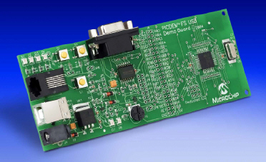

Configuration 2: PIC18F87J50 PIM
1) Short JP4 on the PIC18F87J50 PIM. This allows the demo board to be powered through bus power.
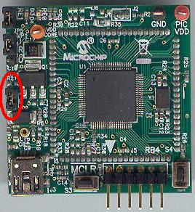

2) Short JP1 such that the “R” and “U” options are shorted.
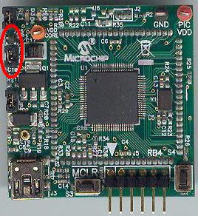

3) Short JP5. This enables the small surface mount LEDs D3 and D4 to function.
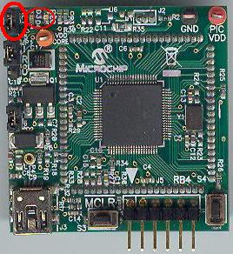

Configuration 3: Explorer 16
1) Before attaching the PIC24FJ256GB110 PIM to the Explorer 16 board, insure that the processor selector switch (S2) is in the “PIM” position as seen in the image below.
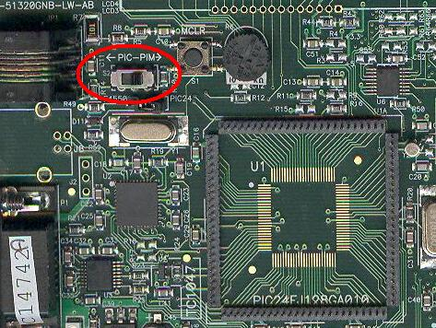

2) Short the J7 jumper to the “PIC24” setting
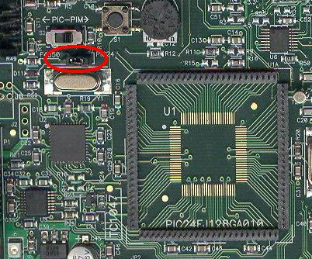

3) Before connecting the PIC24FJ256GB110 PIM to the Explorer 16 board, remove all attached cables from both boards. Connect the PIC24FJ256GB110 PIM to the Explorer 16 board. Be careful when connecting the boards to insure that no pins are bent or damaged during the process. Also insure that the PIM is not shifted in any direction and that all of the headers are properly aligned.

4) On the USB PICTail Plus board, short jumper JP1. Remove all other shorts on the board.
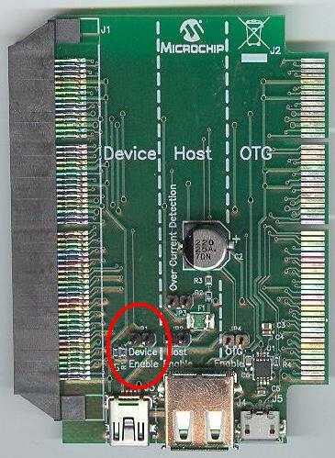

5) Connect the USB PICTail Plus board to either of the female PICTail Plus connectors or on the card edge connector (J9) at the edge of the Explorer 16 board.

Configuration 4: Low Pin Count USB Development Kit
1) Short pins 2 and 3 of J14
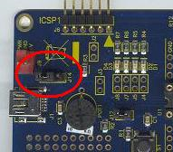

Configuration 5: PIC24F Starter Kit 1
The PIC24F Starter Kit does not require any hardware setup to run this demo. This demo does, however, require the user to change the default selected device in the project before compiling the demo.
1) Open the associated project file for C30
2) In MPLAB Select “Configure->Select Device”
3) In the device list box in the top left corner of that window, select “PIC24FJ256GB106”

Configuration 6: PIC18F46J50 Full Speed USB Demo Board
1) Short JP3 to allow the board to be powered from the USB.

Firmware:
To run this project, you will need to load the corresponding firmware into the microcontroller. Precompiled Demos are available in the “<Install Directory>\USB Precompiled Demos” folders. Each demo hex filename should include information regarding the hardware platform it is compiled for. For this demo, select the appropriate “LibUSB – Generic Driver Demo” hex files that matches the hardware configuration that you plan to use.

For more information about how to load a precompiled project, please see the “Getting Started – Loading a precompiled demo” guide.

The source code for this demo firmware is available in the “<Install Directory\ USB Device - LibUSB - Generic Driver Demo\LibUSB Simple Demo - Firmware” directory. In this directory you will find all of the user level source and header files as well as project and workspace files for each of the hardware platforms.

Please note that when using either the C30 or C32 demo projects you will be required to select the correct processor for the demo board.
1) Open the associated project file
2) In MPLAB Select “Configure->Select Device”
3) In the device list box in the top left corner of that window, select the desired device.

For more help on how to compile and program projects, please refer to the MPLAB® IDE help available through the help menu of MPLAB (Help->Topics…->MPLAB IDE).

Running the Demo (Windows):
This demo uses the selected hardware platform as a Libusb class USB device. Libusb-Win32 is a USB Library for the Windows operating systems. The library allows user space applications to access any USB device on Windows in a generic way without writing any line of kernel driver code. This driver allows users to have access to interrupt, bulk, and control transfers directly.

The SimpleLibUSBDemo.exe program and the associated firmware demonstrate how to use the Libusb device drivers for basic general purpose USB data transfer. To make the PC source code as easy to understand as possible, the demo has deliberately been made simple, and only sends/receives small amounts of data.

Before you can run the SimpleLibUSBDemo.exe executable, you will need to have the Microsoft® .NET Framework Version 2.0 Redistributable Package (later versions probably okay, but not tested) installed on your computer. Programs which were built in the Visual Studio® .NET languages require the .NET redistributable package in order to run. The redistributable package can be freely downloaded from Microsoft’s website. Users of Windows Vista® operating systems will not need to install the .NET framework, as it comes pre-installed as part of the operating system.

The source code for SimpleLibUSBDemo.exe file was created in Microsoft Visual C++® 2008 Express Edition. The source code can be found in the “<Install Directory>\ USB Device - Libusb - Generic Driver Demo\ Libusb Simple Demo - Windows Application\Libusb Simple Demo - PC Application - MS VC++ 2008 Express” directory. Microsoft currently distributes Visual C++ 2008 Express Edition for free, and can be downloaded from Microsoft’s website.

To launch the application, simply double click on the executable “SimpleLIbusbDemo.exe” in the “<Install Directory>\USB Device - Libusb - Generic Driver Demo” directory. A window like that shown below should appear:

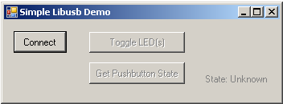

If instead of this window, an error message pops up while trying to launch the application, it is likely the Microsoft .NET Framework Version 2.0 Redistributable Package has not yet been installed. Please install it and try again.

In order to begin sending/receiving packets to the device, you must first find and “connect” to the device. As configured by default, the application is looking for HID class USB devices with VID = 0x04D8 and PID = 0x0204. The device descriptor in the firmware project meant to be used with this demo uses the same VID/PID. To run the demo program the USB device with the correct precompiled .hex file. If you are connecting the device for the first time, Windows pops up a window asking you to install the driver for the device. When asked for the driver point it to the inf file provided along with the demo. Windows takes while to install the driver for the USB device that is just plugged in. Open the Device manager and ensure that the USB device is listed under the ‘Libusb Demo Devices’. Once the driver is installed hit the “Connect” button, the other pushbuttons should become enabled. If hitting the connect button has no effect, it is likely the USB device is either not connected, or has not been programmed with the correct firmware.

Hitting the Toggle LED(s) should send a single packet of general purpose generic data to the Custom class USB peripheral device. The data will arrive on the Bulk OUT endpoint. The firmware has been configured to receive this generic data packet, parse the packet looking for the “Toggle LED(s)” command, and should respond appropriately by controlling the LED(s) on the demo board.

The “Get Pushbutton State” button will send one packet of data over the USB to the peripheral device (to the Bulk OUT endpoint) requesting the current pushbutton state. The firmware will process the received Get Pushbutton State command, and will prepare an appropriate response packet depending upon the pushbutton state.

For hardware configuration 1 (PICDEM FS USB Demo Board), the firmware will check pushbutton “S2” (RB4).
For hardware configuration 2 (PIC18F87J50 PIM), the firmware will check pushbutton “S4” (RB4).
For hardware configuration 3 (Explorer 16), the firmware will check pushbutton “S3” (RD6).
For hardware configuration 4 (Low Pin Count USB Development Kit), the firmware will check pushbutton “S1” (RA3).
For hardware configuration 5 (PIC24F Starter Kit 1), the pushbutton functionality is not implemented in this demo at this point of time.

The PC then requests a packet of data from the device (which will be taken from the Bulk IN endpoint). Once the PC application receives the response packet, it will update the pushbutton state label.

Try experimenting with the application by holding down the appropriate pushbutton on the demo board, and then simultaneously clicking on the “Get Pushbutton State” button. Then try to repeat the process, but this time without holding down the pushbutton on the demo board.

To make for a more fluid and gratifying end user experience, a real USB application would probably want to launch a separate thread to periodically poll the pushbutton state, so as to get updates regularly. This is not done in this simple demo, so as to avoid cluttering the PC application project with source code that is not related to USB communication.

In order to build the application, copy the file <libusb-win32 unzipped folder>\ libusb-win32-device-bin-0.1.12.1\lib\msvc\libusb.lib and paste to ‘lib’ folder of the VC++. Also copy the file
<libusb-win32 unzipped folder>\ libusb-win32-device-bin-0.1.12.1\ include\usb.h and paste to the ‘include’ folder of the VC++.

Running the Demo (Linux):
The SimpleLibUSBDemo program and the associated firmware demonstrate how to use the Libusb device drivers for basic general purpose USB data transfer. To make the PC source code as easy to understand as possible, the demo has deliberately been made simple, and only sends/receives small amounts of data.

Before you can run the SimpleLibUSBDemo executable, you will need to have the libusb 0.1 driver installed on your computer. The libusb can be downloaded from sourceforge.net.

The source code for SimpleLibUSBDemo.exe file was created using QT3 Designer. The source code can be found in the “<Install Directory>\ USB Device - Libusb - Generic Driver Demo\Libusb Simple Demo - Linux Application\ Libusb Simple Demo - Linux Application -QT3” directory.

To launch the application, open the Terminal and navigate to the “SimpleLIbusbDemo.exe” in the “<Install Directory>\USB Device - Libusb - Generic Driver Demo” directory and execute the command “sudo ./SimpleLibusbDemo”. Enter the Super user password when requested. A window like that shown below should appear:

In order to begin sending/receiving packets to the device, you must first find and “connect” to the device. As configured by default, the application is looking for HID class USB devices with VID = 0x04D8 and PID = 0x0204. The device descriptor in the firmware project meant to be used with this demo uses the same VID/PID. To run the demo program the USB device with the correct precompiled .hex file. If you are connecting the device for the first time, Windows pops up a window asking you to install the driver for the device. When asked for the driver point it to the inf file provided along with the demo. Windows takes while to install the driver for the USB device that is just plugged in. Open the Device manager and ensure that the USB device is listed under the ‘Libusb Demo Devices’. Once the driver is installed hit the “Connect” button, the other pushbuttons should become enabled. If hitting the connect button has no effect, it is likely the USB device is either not connected, or has not been programmed with the correct firmware.

Hitting the Toggle LED(s) should send a single packet of general purpose generic data to the Custom class USB peripheral device. The data will arrive on the Bulk OUT endpoint. The firmware has been configured to receive this generic data packet, parse the packet looking for the “Toggle LED(s)” command, and should respond appropriately by controlling the LED(s) on the demo board.

The “Get Pushbutton State” button will send one packet of data over the USB to the peripheral device (to the Bulk OUT endpoint) requesting the current pushbutton state. The firmware will process the received Get Pushbutton State command, and will prepare an appropriate response packet depending upon the pushbutton state.

For hardware configuration 1 (PICDEM FS USB Demo Board), the firmware will check pushbutton “S2” (RB4).
For hardware configuration 2 (PIC18F87J50 PIM), the firmware will check pushbutton “S4” (RB4).
For hardware configuration 3 (Explorer 16), the firmware will check pushbutton “S3” (RD6).
For hardware configuration 4 (Low Pin Count USB Development Kit), the firmware will check pushbutton “S1” (RA3).
For hardware configuration 5 (PIC24F Starter Kit 1), the pushbutton functionality is not implemented in this demo at this point of time.

The PC then requests a packet of data from the device (which will be taken from the Bulk IN endpoint). Once the PC application receives the response packet, it will update the pushbutton state label.

Try experimenting with the application by holding down the appropriate pushbutton on the demo board, and then simultaneously clicking on the “Get Pushbutton State” button. Then try to repeat the process, but this time without holding down the pushbutton on the demo board.

To make for a more fluid and gratifying end user experience, a real USB application would probably want to launch a separate thread to periodically poll the pushbutton state, so as to get updates regularly. This is not done in this simple demo, so as to avoid cluttering the PC application project with source code that is not related to USB communication.

Trademarks:
The Microchip name and logo, the Microchip logo, MPLAB, and PIC are registered trademarks of Microchip Technology Incorporated in the U.S.A. and other countries.
PICDEM and PICTail are trademarks of Microchip Technology Incorporated in the U.S.A. and other countries.
Microsoft, Windows, Visual Studio, Visual C++, and Windows Vista are either registered trademarks or trademarks of Microsoft Corporation in the United States and/or other countries.

